John Q. Student
February 12, 2014
HW 09

– Use this format for the binomial distribution part of the homework
– Be sure to print in Portrait (not Landscape) orientation
– It's probabiliy easier to take a 'snapshot' of Table 1 in Excel and paste into a Word document as a photo.

Table 1. Probability Distribution for Results of Ten Coin-Flips

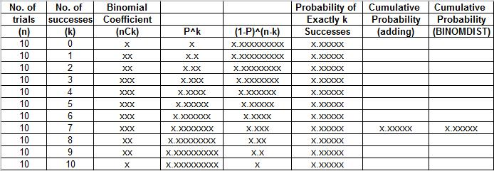

Figure 1. Probability Distribution for Results of Ten Coin-Flips

